**Year 12 ATAR Human Biology**

**Task 3 – Endocrine & Nervous Written Test**

**Weighting: 5%**

**Section 1 - Multiple-Choice (25 marks)**

**Do not write on any part of this sheet. Indicate your answers in the multiple-choice answer grid on the front page of your test.**

1. The synapse is:

a. the sensory fibre of neurons

b. the gap between neurons

c. the path of a reflex arc

d. the membranes covering the brain

2. Which forms the largest part of the brain?

a. cerebrum

b. cerebellum

c. medulla oblongata

d. dura mater

*The next two questions refer to the following diagram:*

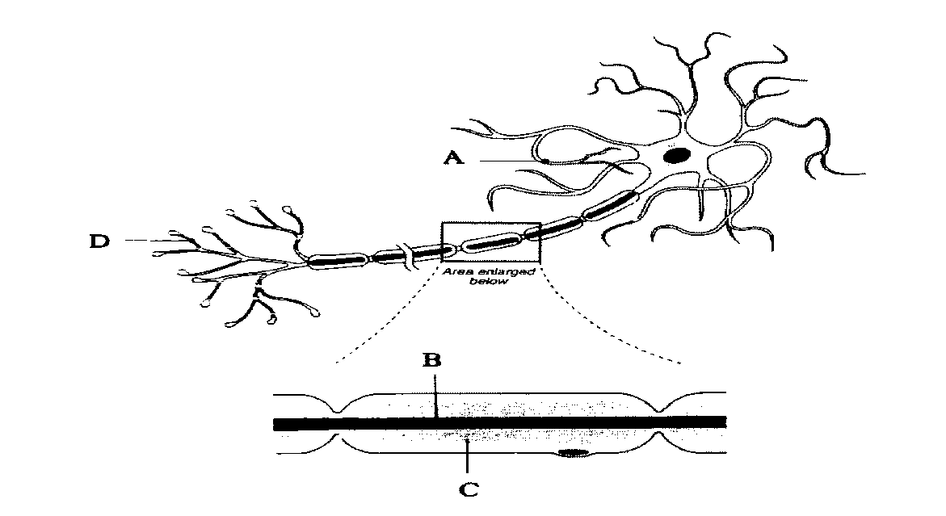

3. Which part of the structure shown above increases the speed of nerve impulse transmission?

a. A

b. B

c. C

d. D

4. Which of the following statements about the cell shown above is correct?

a. This neuron does not show evidence of a Schwann cell.

b. Structure B will produce the myelin sheath.

c. Structure D receives impulses from other neurons.

d. Structure A transmits impulses towards the cell body.

5. In passing from connector to motor neurons, the impulse travels outward by way of:

a. a dendrite to an axon

b. a ganglion to an axon

c. an axon to a dendrite

d. a sensory neuron to a motor neuron

*The next question refers to the diagram below*

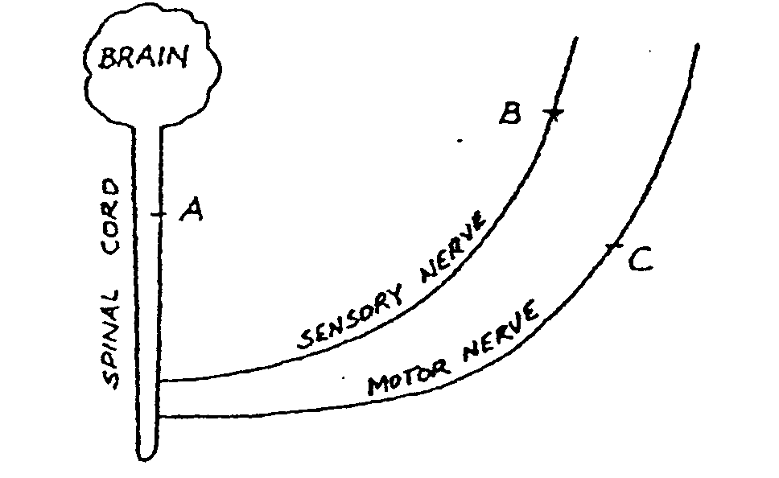

*Letters A, B and C represent regions of the nervous system of a man which might be blocked by a local anaesthetic.*

6. The man can move his toes, but cannot feel the movement. The local anaesthetic must occur at:

a. position A

b. position B

c. position C

d. positions B and C

7. The part of the brain responsible for higher mental activities such as memory, imagination, thought and intelligence is:

a. cerebral cortex

b. cerebellum

c. medulla oblongata

d. pituitary gland

8. Which of the following are not part of a reflex arc?

a. sensory nerve fibre

b. motor nerve fibre

c. connector neuron

d. central canal of spinal cord

9. Sensory neurons connect

a. the brain and spinal cord to muscles and glands

b. sense organs and receptors to muscles and glands

c. one sense organ to another sense organ

d. sense organs and receptors to the brain and spinal cord

*The next question refers to the following diagram*

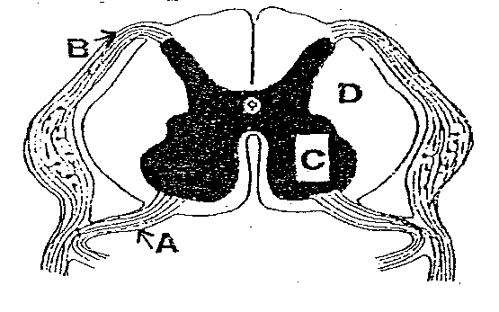10. The areas labelled A, B and C, respectively are:

a. ventral nerve root, dorsal nerve root, grey matter

b. dorsal nerve root, grey matter, white matter

c. connector neuron, dorsal nerve root, grey matter

d. ventral nerve root, dorsal nerve root, white matter

11. The function of the cerebellum is to:

a. initiate impulses involved in the reflex knee jerk action

b. coordinate impulses concerned with muscular tone and balance

c. control breathing rate, particularly during exercise

d. receive impulses from all incoming motor neurons

12. Which of the following is NOT part of the structure of a typical motor neuron?

a. ganglion

b. nucleus

c. axon

d. dendrite

13. The clear liquid that fills the space around the brain and its covering membranes is:

a. the meninges

b. plasma

c. cerebrospinal fluid

d. lymph

*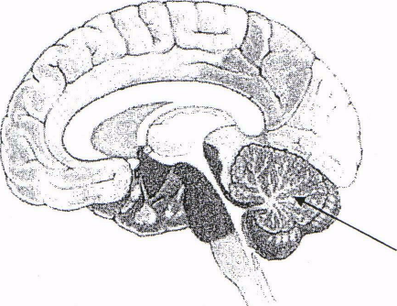The following question refers to the diagram below:*

14. Damage to the structure indicated in the diagram above would result in:

a. Uncoordinated movements

b. Loss of memory

c. Inability to regulate breathing

d. Impaired hearing

15. The ascending tracts contained in the white matter of the spinal cord:

a. Carry nervous impulses down the spinal cord to the ventral root

b. Carry nervous impulses up the spinal cord to the brain

c. Contain motor axons to carry nervous impulses to the peripheral nervous system

d. Contain sensory axons to carry nervous impulses away from the brain

16. The somatic division belongs to which component of the peripheral nervous system?

a. Afferent

b. Autonomic

c. Efferent

d. Parasympathetic

17. Chemicals secreted by cells into the extracellular fluid which regulate the metabolism of other cells are:

a. enzymes

b. drugs

c. hormones

d. neurotransmitters

18. Which of the following statements about ALL hormones is correct?

a. They change the activities of cells

b. Their activity is controlled by the pituitary gland

c. Their activity is controlled by the hypothalamus

d. Each hormone can act on only one specific target organ

19. Oxytocin is released by the:

a. Hypothalamus

b. Anterior pituitary

c. Posterior pituitary

d. Thyroid gland

20. The adrenal glands are physically associated with the:

a. Pancreas

b. Liver

c. Spleen

d. Kidneys

21. Which of the following choices lists only **endocrine** glands?

a. Pituitary gland, salivary gland, thyroid gland

b. Pancreas, liver, pituitary gland

c. Islets of Langerhans, pituitary gland, adrenal gland

d. Parathyroid glands, adrenal glands, kidney

22. Ovulation is produced by a rise in:

a. Luteinising hormone and oestrogen

b. Luteinising hormone and progesterone

c. Follicle stimulating hormone and oestrogen

d. Follicle stimulating hormone and progesterone

23. Antidiuretic hormone is released by the pituitary to:

a. Regulate water content in the kidneys

b. Control calcium and phosphate levels in the blood

c. Control the production and release of hormones from the adrenal cortex

d. Promote normal metabolism and resistance to stress

24. The target organ for glucagon include the:

a. uterine tubes and ovaries

b. Liver and fat cells

c. Proximal and distal convoluted tubules of the nephron

d. Alpha cells in the pancreas

25. Aldosterone is secreted from the:

a. Posterior pituitary

b. Parathyroid gland

c. Adrenal glands

d. Thyroid gland

**END OF SECTION 1**

**Year 12 ATAR Human Biology**

**Task 3 – Endocrine & Nervous Written Test**

**Weighting: 5%**

Name: _______________________________________ Teacher: ___________________________________

|  |  |  |
| --- | --- | --- |
| **Section 1 – Multiple Choice** | **/25** |  |
| **Section 2 – Short Answer** | **/25** |  |
| **Section 3 – Extended Answer** | **/10** |  |
| **TOTAL** | **/60** | **%** |

**Multiple-Choice Answer Grid**

***Place an* X *through the correct response:***

1. [A] [B] [C] [D] 14. [A] [B] [C] [D]

2. [A] [B] [C] [D] 15. [A] [B] [C] [D]

3. [A] [B] [C] [D] 16. [A] [B] [C] [D]

4. [A] [B] [C] [D] 17. [A] [B] [C] [D]

5. [A] [B] [C] [D] 18. [A] [B] [C] [D]

6. [A] [B] [C] [D] 19. [A] [B] [C] [D]

7. [A] [B] [C] [D] 20. [A] [B] [C] [D]

8. [A] [B] [C] [D] 21. [A] [B] [C] [D]

9. [A] [B] [C] [D] 22. [A] [B] [C] [D]

10. [A] [B] [C] [D] 23. [A] [B] [C] [D]

11. [A] [B] [C] [D] 24. [A] [B] [C] [D]

12. [A] [B] [C] [D] 25. [A] [B] [C] [D]

13. [A] [B] [C] [D]

**Section 2 – Short Answer (25 marks)**

Write your responses in the spaces provided

26. Complete the table comparing the nervous and endocrine systems. [5]

|  |  |  |
| --- | --- | --- |
| **CHARACTERISTIC** | **ENDOCRINE SYSTEM** | **NERVOUS SYSTEM** |
| Nature of message |  |  |
| Transport of message |  |  |
| Specificity of action |  |  |
| Speed of response |  |  |
| Duration of response |  |  |

27. *This question refers to the diagram below.*

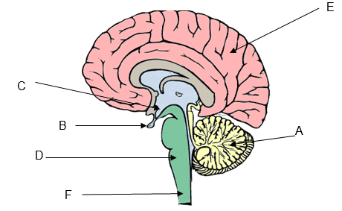

Identify the parts of the central nervous system labelled A-F and briefly state the function of each. [6]

|  |  |  |
| --- | --- | --- |
| Label | Name | Function |
| A |  |  |
| B |  |  |
| C |  |  |
| D |  |  |
| E |  |  |
| F |  |  |

28. Steroid hormones affect target cells different to protein and amine hormones.

a. Briefly explain how steroid hormones affect target cells. [2]

b. Briefly explain how protein and amine hormones affect target cells. [2]

29. Compare the actions of the sympathetic and parasympathetic nervous systems on the following organs and tissues. [5]

|  |  |  |
| --- | --- | --- |
| Organ/Tissue | Sympathetic Nervous System | Parasympathetic Nervous System |
| Heart |  |  |
| Pupils |  |  |
| Lungs |  |  |
| Blood vessels of skeletal muscles |  |  |
| Sweat glands |  |  |

30. Name two hormones secreted by the anterior lobe of the pituitary gland and state the function of each. [2]

31. The following flow chart represents the way in which the thyroid gland and its secretions are under the control of the hypothalamus.

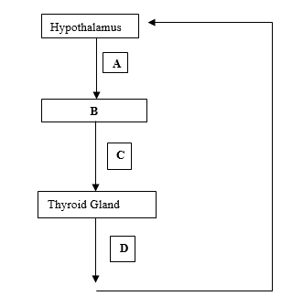

a. Identify secretions A, C and D and structure B. [2]

Secretion A:

Secretion C:

Secretion D:

Structure B:

b. State two effects of secretion D on the body. [1]

**END OF SECTION 2**

**Section 3 – Extended Answer (10 marks)**

Write your response in the space provided.

32. Describe the reaction that would occur if a person walking along the beach trod on a sharp piece of glass. Include in your answer a description of the pathway taken by the nerve impulses. A well labelled diagram should be included to illustrate your description. [10]